7.3 Electroplating
Name: ____________________ Class: ____________________ Due date: 1.6
1. The table gives the compounds electrolysed and the electrodes used.
 | substance electrolysed | electrodes
1 | concentrated hydrochloric acid | carbon
2 | concentrated sodium chloride | platinum
3 | molten lead bromide | platinum
In which experiments is a gas evolved at the cathode? （ ）
A 1, 2 and 3 B 1 and 2 only C 1 only D 3 only

2. The diagram shows a failed attempt to copper- plate a pan.
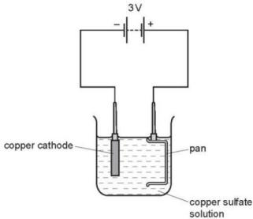
Which action will plate the pan with copper? （ ）
A cooling the copper sulfate solution in an ice bath
B heating the copper sulfate solution to boiling point
C increasing the voltage from 3V to 6V
D making the pan the cathode and the copper the anode

3. Winston Churchill,British Prime Minister, had his false teeth electroplated with gold.
The teeth were coated with a thin layer of carbon and were then placed in the apparatus shown.
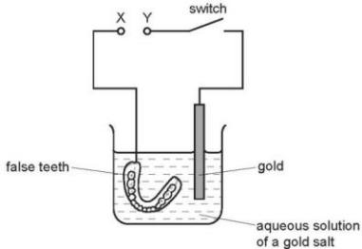
Which row is correct? （ ）
 | terminal X is | the carbon powder could be
A | negative | diamond
B | negative | graphite
C | positive | diamond
D | positive | graphite
4 .Which metal could not be used for electroplating by using an aqueous solution? （ ）
A chromium B copper C silver D sodium
5. Which apparatus could be used to electroplate an iron nail with copper? （ ）
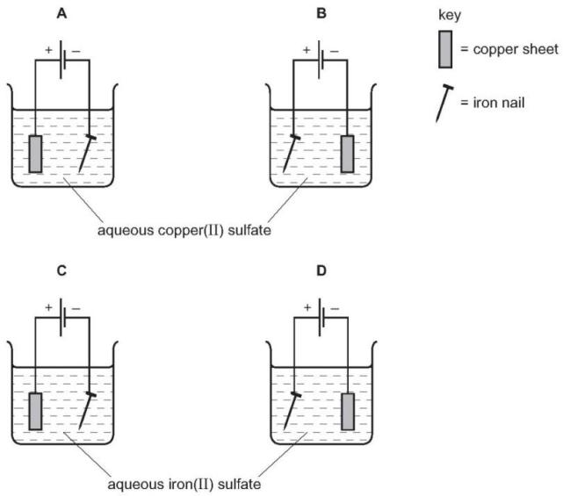
6. The diagram shows an electrolysis experiment using metals X and Y as electrodes.
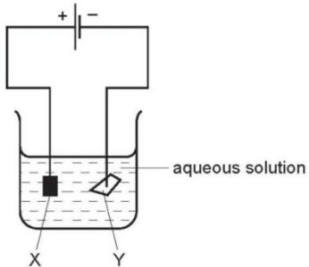
One of the metals becomes coated with copper.
Which metal becomes coated and which aqueous solution is used? （ ）
 | metal | aqueous solution
A | X | CrCl₃
B | X | CuCl₂
C | Y | CrCl₃
D | Y | CuCl₂

7. The diagram shows the electroplating of a steel object.
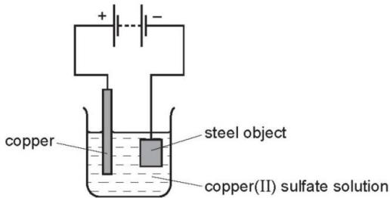
A student made the following statements.
1 The object turns a reddish- brown colour.
2 The copper sulfate solution changes to a paler blue colour.
3 The copper electrode becomes smaller.
Which statements are correct? （ ）
A 1, 2 and 3 B 1 and 2 only C 1 and 3 only D 2 and 3 only
8. An object is electroplated with silver using an aqueous silver salt as the electrolyte.
Which set of conditions is used? （ ）
 | the object to be electroplated is the | the other electrode is made from
A | anode | carbon
B | anode | silver
C | cathode | carbon
D | cathode | silver

9. Which rows correctly show cathode and anode products from the electrolysis of the named electrolyte? （ ）
 | electrolyte | cathode product | anode product
1 | copper(II) sulfate solution using copper electrodes | copper | oxygen
2 | molten lead(II) bromide | lead | bromine
3 | dilute sodium bromide solution | hydrogen | oxygen
4 | copper(II) sulfate solution using carbon electrodes | hydrogen | oxygen
A 1 and 2 only B 1 and 4 only C 2 and 3 only D 3 and 4 only

10. Electroplating steel objects with silver involves a three- step process.
step 1 A coating of copper is applied to the object.
step 2 A coating of nickel is applied to the object.
step 3 The coating of silver is applied to the object.
a.A diagram of the apparatus used for step 1 is shown.
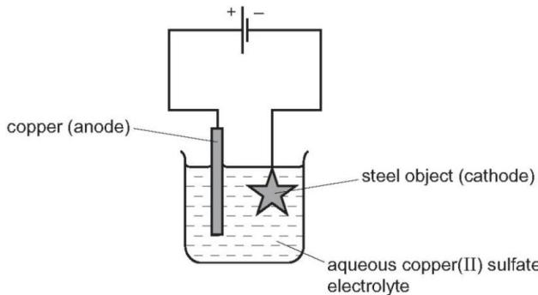
ii.Explain why the concentration of copper ions in the electrolyte remains constant throughout step 1.
.................................................................................................................................................................................................................................................................................................................................................................................................................. [2]
b.Give two changes which would be needed in order to coat nickel onto the object in step 2.
...................................................................................................................................................................................................................................................................................................................................................................................................................[2]
11. Electrolysis of concentrated aqueous sodium chloride using inert electrodes forms chlorine, hydrogen and sodium hydroxide.
a.What is meant by the term electrolysis?
............................................................................................................................................................................................................................................................
b.Name a substance that can be used as the inert electrodes.
..................................................................................................................................
c.Give two reasons why it is suitable to use as an electrode.
1............................................................................................................................................................................................................................................................
2....................................................................................................................................................................................................................................................... [2]

